# A GIS model for mapping forested riparian buffers using LiDAR-derived canopy height maps

## Introduction

Forested riparian buffers provide many important ecosystem services, for instance: Nitrogen and sediment removal (Hill 1996, Sweeney and Newbold 2014); channel width increase (B. T. Sweeney 2004); bank stability (Beeson and Doyle 1996); temperature control (Moore and Story 2005); large woody debris (Maser and Sedell 1994); and fish and invertebrate habitat (Brazner and Snarski 2005, B. 1. Sweeney 1993).

The width of a buffer is one important factor determining the strength of the services provided. The recommended width varies greatly based on unique landscape characteristics such as slope, rainfall, and soil type (Vidon 2006, Xiang 1995). It is also dependent on the ecosystem service being targeted, but in general a forested buffer at least 10m or 30m wide provides many of the desired services (Sweeney and Newbold 2014).

Due to their proven value, many national and regional best management practice guidelines include provisions for maintenance and reestablishment of forested riparian buffers (Broadmeadow and Nisbet 2004, Johnson and Buffler 2008, Lee, Smyth and Boutin 2004, Palone and Todd 1998). These programs require consistent and affordable monitoring of riparian buffers in order to evaluate their application (Hairston-Strange 2002, Claggett, Okay and Stehman, Monitoring Regional Riparian Forest Cover Change Using Stratified Sampling and Multiresolution Imagery 2010).

Two of the most common methods used to monitor buffers are human interpretation of aerial photography, and automated computer interpretation of satellite imagery. Each has its own distinct advantages and disadvantages, and neither method has proven entirely satisfactory. Human interpretation is the more accurate of these two methods, but it is difficult to apply repeatedly or over large areas as it requires a significant time investment from GIS technicians (Lattin, et al. 2004, Owers, Albanese and Litts 2011). This method can benefit from a sampling schema in which only areas prone to change are reassessed, but this requires expert knowledge and again restricts large-scale application (Claggett, Okay and Stehman, Monitoring regional riparian forest cover change using stratified sampling and multiresolution imagery 2010). Automated computer interpretation of satellite imagery can be used to assess much larger areas with minimal human input, but has suffered from resolution issues where the input data source has been the Landsat Thematic Mapper, which has a 30m pixel resolution and is therefore unsuitable for assessing buffers at the lower resolutions (i.e.: 5m-10m) desired (Lattin, et al. 2004, Congalton, et al. 2002). Commercial satellites IKONOS, QuickBird, and OrbView3 can provide imagery at the required resolution (<4m), but have a high per-image acquisition cost, making them unideal for large scale projects or for use by agencies with limited funding (Goetz 2006) .

A third method for monitoring forested riparian buffers using LiDAR-derived canopy height maps has been discussed, but as yet has seen only a few implementations (Wasser, et al. 2014). LiDAR instruments provide detailed surface topography information, and can be used to develop accurate, high-resolution (1m-20m) canopy height maps (Dubayah and Drake 2000). Commercial LiDAR systems are increasingly prevalent in the United States, and are able to provide affordable data coverage over an entire state (Goetz 2006).

This project aims to tackle some of the issues surrounding consistent monitoring of forested riparian buffers, and provide a reusable method of mapping them which can easily be applied by agency officials and GIS technicians tasked with this goal. By using recent advances in the popular ArcMap program (ESRI), we were able to design an ArcMap tool which automatically generates a map of forested riparian buffers and calculated buffer widths at every stretch of an input stream. The tool was used, along with a 1m resolution LiDAR-derived canopy cover map over the state of Maryland, to develop a buffer map of the state, and the process and results are presented in the remainder of this paper.

## Data

This tool relies on two input data sets: A stream hydrology dataset, and a canopy cover map. Accurate, high-resolution data is required for optimal outputs. For the state of Maryland, a subset of the National Hydrography Dataset was selected, and a 1m resolution LiDAR-derived canopy cover map. Users of the tool are recommended to use similar data sets to analyze their own areas of interest wherever available, due to the aforementioned benefits of high resolution LiDAR data.

The stream hydrology input dataset was downloaded from the National Hydrography Dataset (USGS). I used the Hydrography NHDFlowline subset, a polyline feature class with an indicator for type of hydrography. This was subset to include only those features with an “FType” value of 460, which is reserved for streams and rivers. I projected the data to NAD 1983 UTM zone 18N, except for Garrett and Alleghany counties, which were projected to NAD 1983 UTM zone 17N. Using the ArcGIS “Split” tool, the input hydrology dataset was split into individual sets for each county to allow for piece-wise processing.

Input canopy cover maps were provided by *Dubayah et al.* These maps are LiDAR derived and available at a 1m-2m resolution. One map was provided for each county. At the time of this writing, these maps are available to be viewed at Maryland’s GIS portal at: <https://geodata.md.gov/imap/rest/services/Biota/>

* This data will also let you see the contiguous length of buffers, which is important (Wahl, Neils and Hooper 2013)

## Methods

///Output:

1. A copy of the input hydrology layer, split into 10m intervals, with two additional fields denoting the width of the forested riparian buffer on either side. An additional eight fields are included as a convenience, indicating the number of buffer sides (0/1/2) at each interval greater than a set buffer width (7m/15m/30m/45m/60m/75m/90m).
2. A forested riparian buffer map in the form of 10m long swaths along each side of the input hydrology layer, extending up to the maximum buffer width (250m), and clipped to include only those parts considered a part of the forested riparian buffer. Each swath contains a field indicating its buffer width in meters.///

The tool was developed as an arcpy toolbox using the python programming language. The process is summarized in Figure 2, and described in more detail in the remainder of this section. At the end of this section, additional optional input parameters are discussed.

Process

Legend:

1. Dissolve lines into single feature
2. Split line at 10m interval
3. Assign unique TransectID to each interval
4. s
5. interval
6. Buffer hydrology data by 100m
7. Clip canopy cover to buffer
8. Convert clipped canopy cover to polygon
9. Extract polygons where “Value” = 1
10. Build 100m long perpendicular transects at each 10m interval
11. Buffer transects by 5m with flat ends
12. Clip resulting 10m swaths to Rough FRB Perimeter
13. Convert resulting multipart polygons into single part polygons
14. Extract polygons within tolerated distance of input hydrology
15. Calculate area of FRB swath using Geometry Calculator
16. Calculate FRBWidth as *width = area *1/10*
17. Calculate FRBWidth1 and FRBWidth2 by matching TransectIDs
18. Calculate # of FRB exceeding set widths (0,7,15,30,45,60,75,90)

Figure 2 - Overview of Process

### Step 1: Split Hydrology

1. Dissolve lines into single feature
2. Split line at 10m interval
3. Assign unique TransectID to each interval

interval

Creating the split hydrology shapefile is a straightforward process. The code to split lines at even intervals was provided by *Map Rantala, 2011.*

### Step 2: Rough FRB Perimeter

1. Buffer hydrology data by 100m
2. Clip canopy cover to buffer
3. Convert clipped canopy cover to polygon
4. Extract polygons where “Value” = 1

A rough forested riparian buffer perimeter is output as an intermediary layer in order to later detect connected regions with canopy cover, which are classified as a part of the final FRB. The raster is first clipped to within 100m of the input hydrology in order to eliminate any processing performed outside of the area of interest. Figure 2 shows the results of this process. Many of these polygons will be clipped or removed in the final output. A few, but not all, such polygons are circled in Figure 2 to demonstrate this.

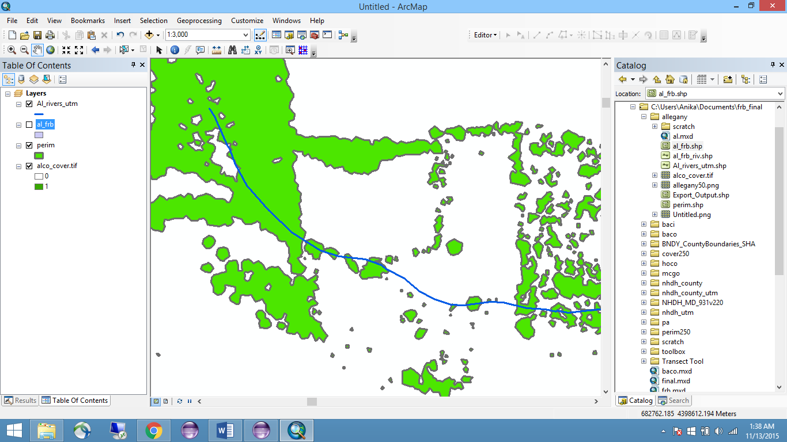

**Legend:**

Input Hydrology

Rough FRB Perimeter

Not in FRB – will be removed in final output!

Figure 3 - Polygons of Rough FRB Perimeter

### Step 3: Forested Riparian Buffer Swaths

Build 100m long perpendicular transects at each 10m interval

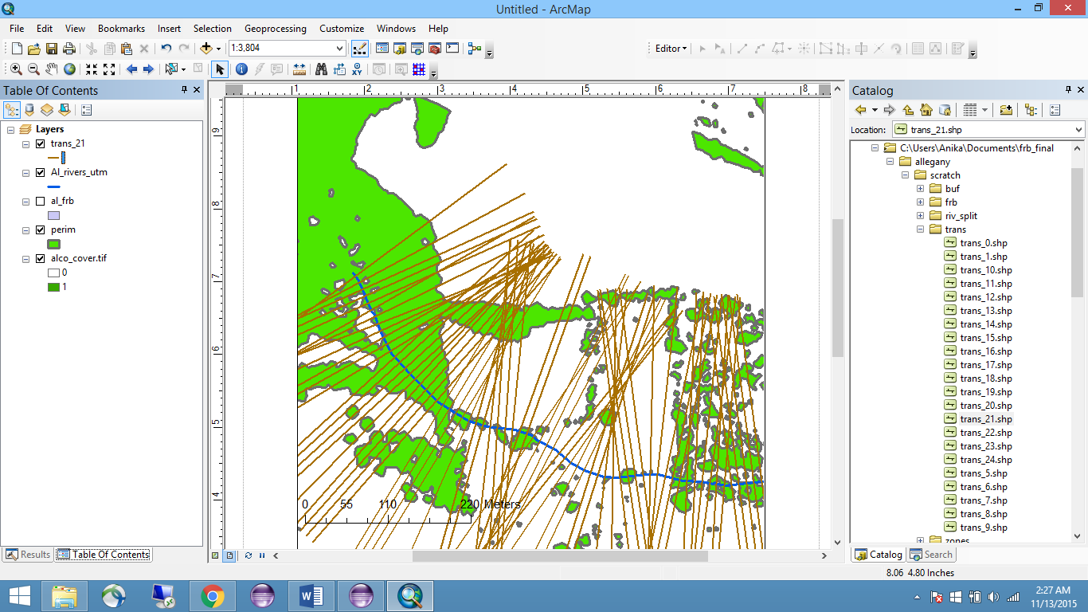

Buffer transects by 5m with flat ends

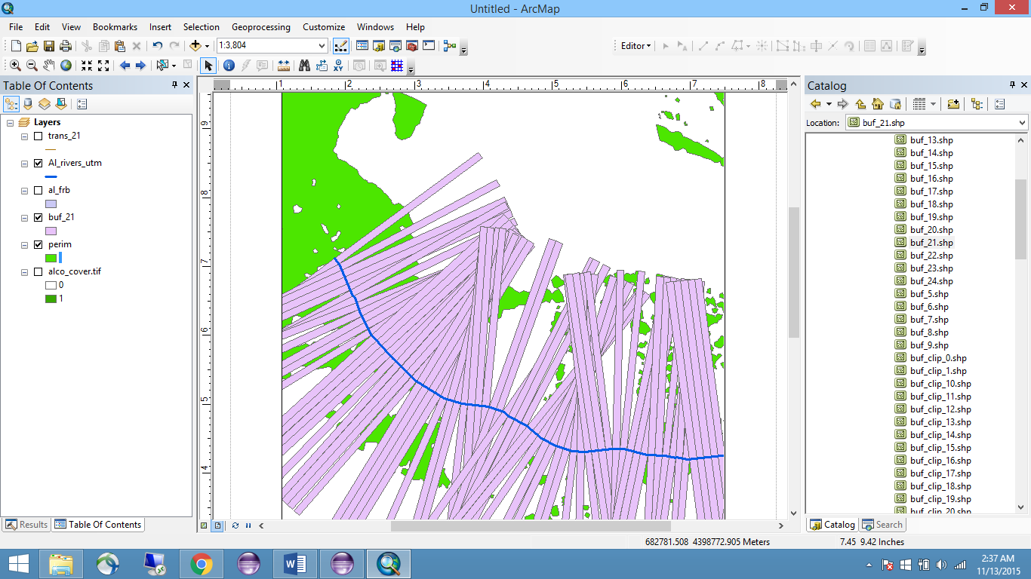

Clip resulting 10m x 100m swaths to Rough FRB Perimeter

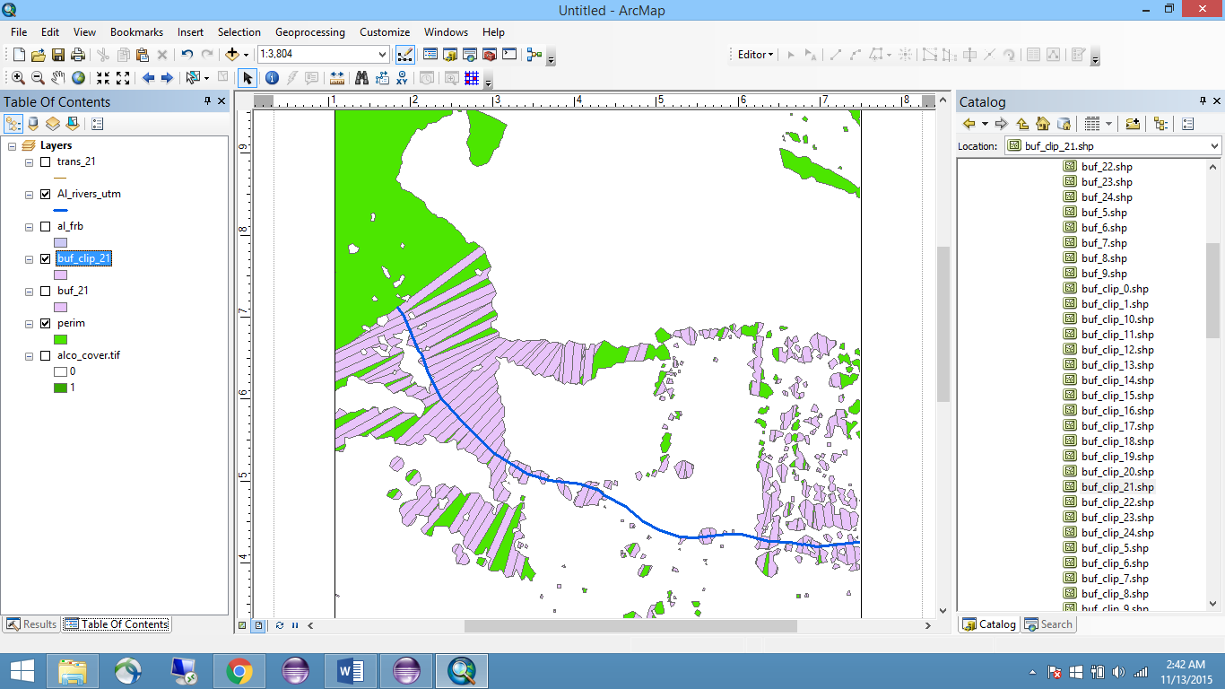

Convert resulting multipart polygons into single part polygons

Extract polygons within tolerated distance of input hydrology

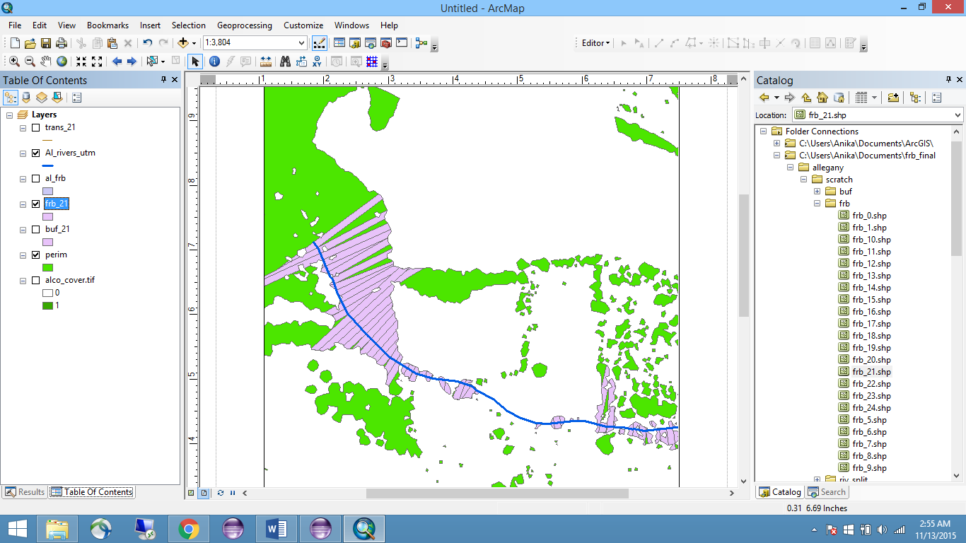

**Forested Riparian Buffer**

Opposing transects are assigned the same TransectID, and marked as Side 1 or 2.

Figure 4 – Detailed diagram of method for determining FRB membership

Figure 4 presents a visual walk-through of the steps taken to determine membership in the forested riparian buffer. The final output will contain only those portions which were contiguous within a 10m wide swath within a small distance from the input hydrology. The default value for this tolerance is 5m. The code for creating perpendicular transects was adapted from an arcpy tool by *Mateus Ferreira, 2014*.

### Step 4: Calculating FRB Width

For each swath in the Forested Riparian Buffer output, two additional fields are created. The first is an “Area” field, which is calculated using the ArcGIS Geometry Calculator. This value will be needed to calculate the second field, “FRBWidth”. “FRBWidth” is approximated as “Area” / 10m, the width of one swath. In some instances, canopy gaps within a swath result in a smaller area that does not quite match the expected formula “Area = length * width”, leading to an underestimate. The resulting differences are small and rare enough for this method to be a reasonable choice.

A field for “FRBWidth1” and “FRBWidth2” is added to the output Split Hydrology feature. Using the arcpy Data Access module and its cursor classes, TransectIDs are matched and these values are copied from the FRB output. Eight additional fields are added to the output Split Hydrology. These fields are: “Num_FRB”, “Over_7”, “Over_15”, “Over_30”, “Over_45”, “Over_60”, “Over_75”, and “Over_90”. Their values are set by summing whether or not either FRBWidth meets or exceeds the indicated width. These fields are added as a convenience to allow users to quickly identify areas of interest on a map.

### Tool Parameters

Several of the values discussed in the methodology are adjustable parameters in the ArcMap tool. They are listed here, with their default value in parentheses: Maximum Buffer Width (100m), Swath Width (10m), Tolerated Distance from Hydrology (5m).

### Additional Processing Information

Processing large datasets can lead to many unforeseen errors within ArcMap. This tool includes a pre-processing step in which the input hydrology dataset is split up into approximately 10km x 10km zones. These zones are processed one at a time, and all files remain on the disk until a final merge is successfully completed. In the event of a system crash, the user can resume the program for any zones not yet handled.

## Results

The results of the analysis over three counties in Maryland are presented below. Non-spatial data is provided in the summary table and histograms. However, the most useful information can be gained by observing the maps, which highlight clusters of smaller buffer widths. These maps also help to identify short breaks in existing buffers, which are detrimental to wildlife habitat goals (Palone and Todd 1998), and could be of interest where this is a priority. The static overview maps presented here are limited in the amount of detail they can provide, and it is recommended that anyone intending to work with this data download the full data set in order to take advantage of the actual precision.

### Summary Table

This table only provides summary information for portions of the stream where *neither* side of the buffer met the minimum width criteria listed. In the subsequent maps, these are shown in red.

|  |  |  |  |  |  |  |
| --- | --- | --- | --- | --- | --- | --- |
| County | **Allegany** | | **Montgomery** | | **Prince George’s** | |
| Streams Assessed | 1389 km | | 1638 km | | 1328 km | |
| No buffers | 77 km | 6% | 148km | 11% | 110km | 7% |
| Both sides < 7m | 113km | 8% | 214km | 16% | 184km | 11% |
| Both sides < 15m | 184km | 13% | 264km | 20% | 249km | 15% |
| Both sides < 30m | 149km | 11% | 350km | 26% | 559km | 34% |
| Both sides < 45m | 212km | 15% | 424km | 32% | 458km | 28% |
| Both sides < 60m | 252km | 18% | 491km | 37% | 781km | 48% |
| Both sides < 75m | 281km | 20% | 553km | 42% | 868km | 53% |
| Both sides < 90m* | 308km | 22% | 624km | 47% | 942km | 58% |
| Both sides > 90m* | 331km | 24% | 298km | 22% | 696km | 42% |

*\* These two values are not expected to add up to 100%. Summary information describing sections where only one side met the criteria has been omitted for clarity, but has been drawn in yellow in the subsequent maps.*

### Histograms – FRB Width Distribution

These histograms show the distribution of buffer widths along all streams assessed. Because buffers are measured on both sides of the stream, the total stream length counted is double that of actual streams assessed.

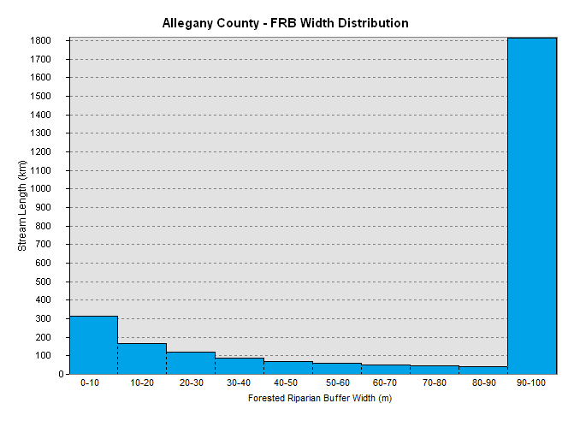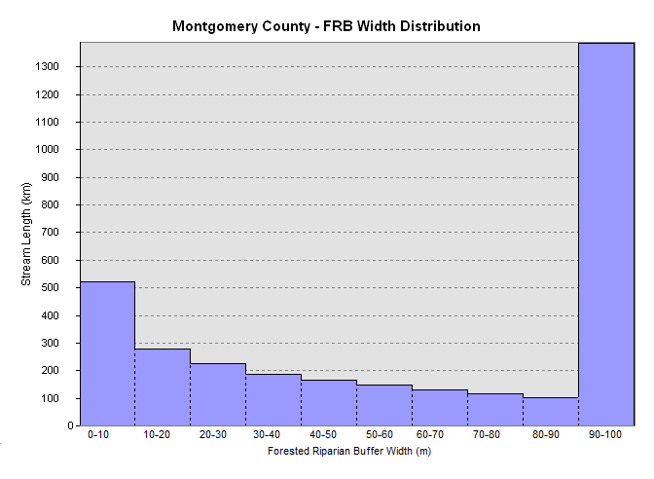

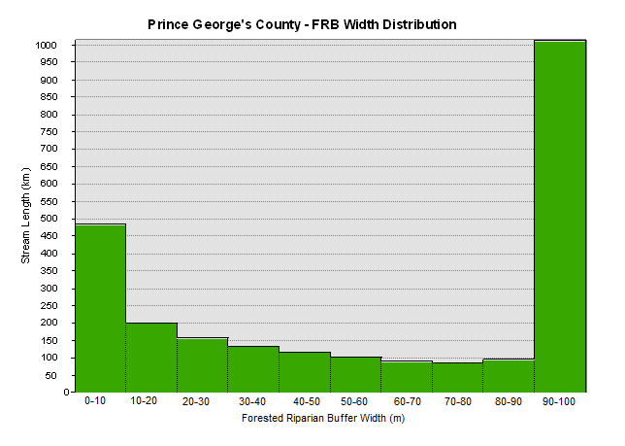

### Maps

A subset of maps displaying number of buffers meeting minimum width criteria at set intervals is displayed here. Additional maps can be found in Appendix A.

### Allegany County

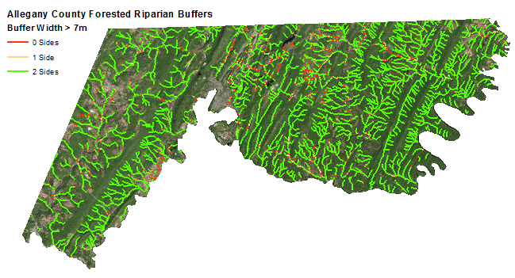

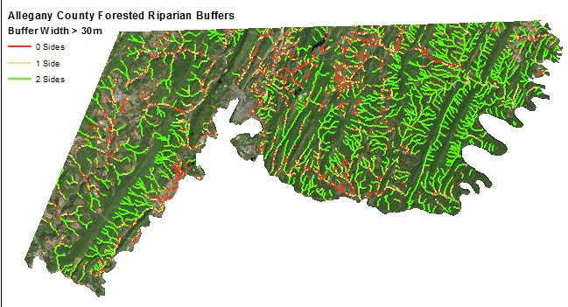

#### Montgomery County

#### 

#### 

#### Prince George’s County

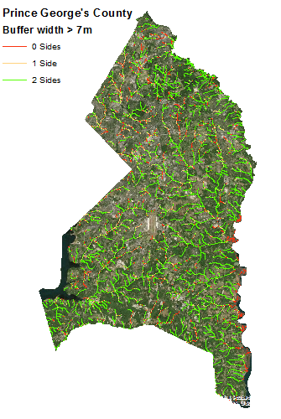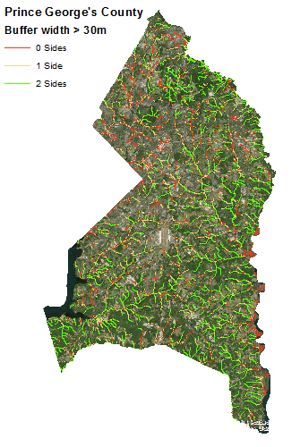

## Discussion

Several factors affect the quality of the output of this tool, which contains both underestimates and overestimates of buffer width. These issues are highlighted here, and are joined by a discussion of how these issues were addressed when developing forested riparian buffer maps of Maryland.

### Approximation of FRB Width

The calculated forested riparian buffer width is only approximate. It is calculated by dividing the area of the buffer swath by the stream-side length of the swath (default 10m). Since each swath continues so long as canopy cover is contiguous within this swath, the resulting swath may include several holes or indentations, reducing the total area and calculated width. Figure 5 shows the calculated width, as well as actual averaged width of several buffer swaths in a subsection of Allegany County. Ultimately, the differences were found to be negligible on a large scale, but warrant further inspection when dealing with precise locations.

|  |  |  |
| --- | --- | --- |
|  | **Estimated Width** | **Actual Width** |
| 1 | 1.6m | 2.4m |
| 2 | 13.6m | 16.5m |
| 3 | 30.8m | 34.7m |
| 4 | 12.1m | 14.8m |
| 5 | 4.8m | 4.8m |
| 6 | 15m | 19.3m |

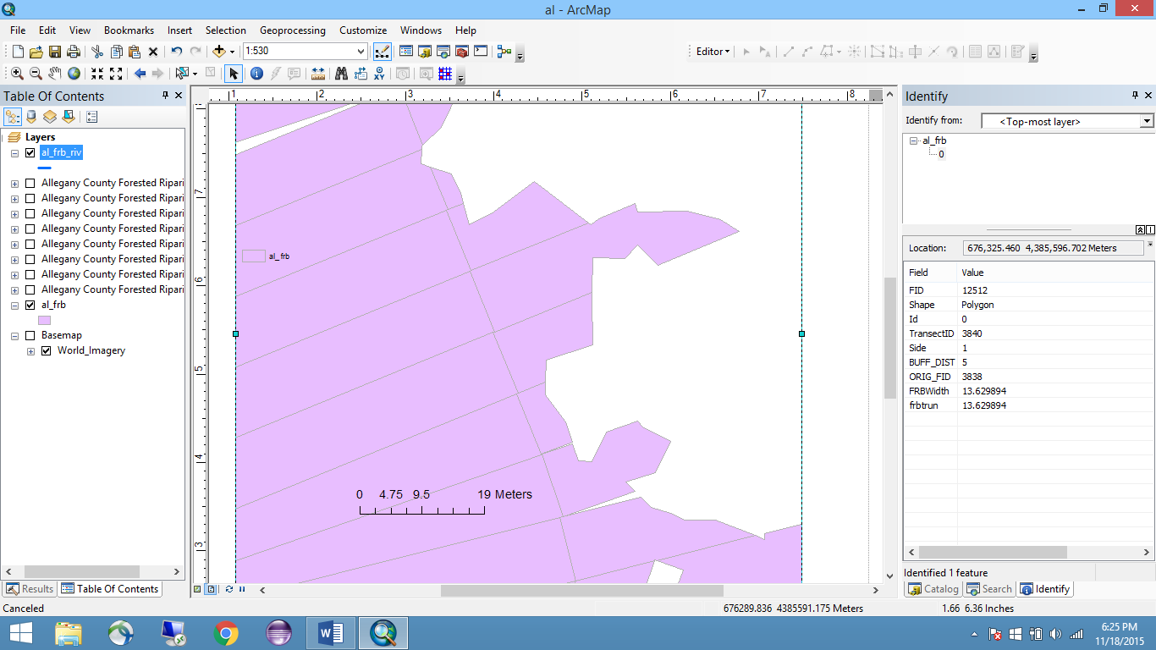

**Legend:**

Input Hydrology

FRB Swaths

6

5

4

3

2

1

Figure 5 - Calculated and Actual FRB Width

Using the adjustable swath width parameter tool, users may reduce these errors by reducing the width to only 5m or less. However, this comes at the cost of increased processing time, as well as an increased lack of forgiveness for small breaks in canopy cover, such as those caused by downed trees. Therefore, it is not recommended to reduce swath width to less than 10m.

### Tolerated Distance Parameter – Allowances for wide riverbanks and off-set buffers

The tolerated distance parameter sets how far from the input hydrology the buffer may begin in order to be considered a part of the buffer. This parameter is necessary when the input hydrology and canopy cover map do not exactly overlap. Especially for slightly wider rivers, this parameter gives the program some leeway in starting the buffer. Figure 8 depicts one scene where, without this parameter, many of the buffers would all be erroneously marked as 0m wide.

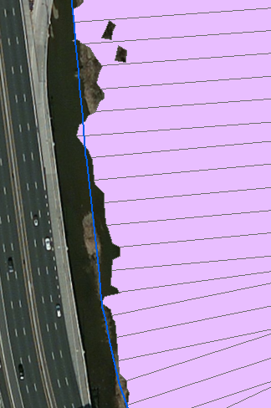

Figure 8 – Would be omitted without Tolerated Distance Parameter

How wide to make this tolerated distance should be determined on a case-by-case basis. A wider tolerance is more forgiving, and can be especially useful if the input hydrology contains polylines demarcating rivers which are several meters wide.* A wider tolerance will also open up room for more error and a resulting overestimate of buffer widths, and should therefore be used cautiously. For processing over the state of Maryland, a 5m tolerated distance was used.

* *Polylines demarcating wide rivers should be avoided. A process for handling these is described further in this section under “Handling Wide Streams, Rivers and other Water Bodies”.*

### Underestimation of FRB Width due to short breaks in canopy cover

The developed tool considers the buffer ended as soon as any portion of the 10m long swath is not connected. This can lead to an underestimate of buffer width. Figure 6 shows one example where the buffer is truncated, even though one would consider it to continue. It is possible to circumvent this behavior by reducing the resolution of the input canopy cover map, so that small gaps are removed prior to processing. While this may sometimes be an appropriate choice, users should keep in mind that not all tiny gaps are irrelevant. Figure 7 depicts a neighborhood, in which the riparian buffer is consistently interrupted by residences. In this case, it would be a mistake to attempt to ignore these small breaks.

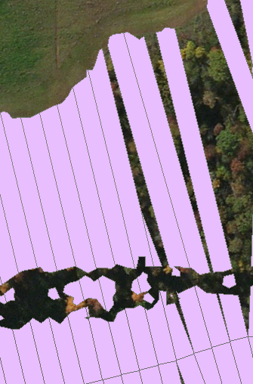 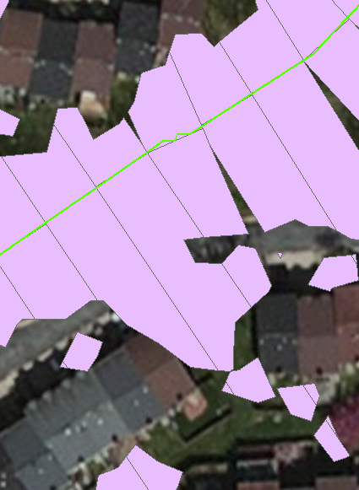

Figure 6 - Actual FRB / Excluded due to gaps Figure 7 – Actual FRB / Would be included If gaps were ignored

For the analysis of Maryland performed in this study, it was decided that it would be best to err on the conservative side. Therefore, no adjustments were made to attempt to continue the buffer when interrupted by a small break. This is especially relevant in Maryland, where many suburban neighborhoods lie adjacent to streams and are a point of interest. Overestimating the buffer width at these points would mean these stressed stream reaches may be accidentally ignored and considered in no need of further attention.

### Overestimation of buffer widths due to connectivity with non-matching stream sections

Occasionally, a buffer swath will include portions which are clearly not connected to the corresponding stream section. This occurs because the ArcMap tool used to select clipped buffer portions within a distance of the input hydrology is not able to match selections based on TransectIDs.

While it would be possible to process each feature individually and ensure the TransectIDs match before performing any clipping, this greatly increases processing time and was not feasible for a large, state-wide data set. For users processing a smaller dataset, it is recommended to perform this as a post-processing step. For the Maryland data processed in this study, it was decided that this was rare enough to warrant being ignored.

It should be noted that these errors occur especially at the intersections of streams, and are more likely to occur when a high maximum buffer width value is set. Therefore, the default maximum value of 100m was used over the state of Maryland, and it is recommended not to use a larger value unless necessary, as this will increase the chance of such an overestimation error.

### Data Processing at Boundaries

The tool does not currently make any special provisions for data at the boundary of the input layers. If a user is working with an input hydrology dataset that often runs parallel to the edge of the input canopy cover map closer than the maximum buffer width parameter, they should be aware that the results may underestimate buffer widths at these points.

For much of the data processed in Maryland, this is not a significant issue. The data was split by county, and most counties are separated by wide rivers, which are a special case described below.

### Handling Wide Streams, Rivers, and other Water Bodies

The current version of the tool is not able to properly process streams or rivers more than a few meters wide. If a river is better represented as a polygon than a polyline, it is probably not appropriate to be input into this tool. Lakes are also not appropriate input for this tool. The input data set used when processing over Maryland was specifically subset to omit any such rivers that may cause a problem.

The basic steps to handle these types of input are described here as a reference. For each wide hydrology feature, a corresponding polygon and polyline must be created. Transects can be built along the polyline as usual, and then subset so that any which are contained in the matching polygon are removed. In this way, only the outer transects remain, and the buffer calculation process can continue as usual. Note that using this method, a maximum of 1 buffer can be calculated for any interval.

Because many of the most important ecosystem services of forested riparian buffers are provided by those found alongside lower order streams, it is not crucial when researching river buffers that these larger rivers be included (Palone and Todd 1998).

## Conclusion

While a few select buffer width intervals were described in this report, these can be adjusted to meet the exact needs of any user. The simple, reusable format of this tool is useful not only for an initial assessment of buffer conditions, but also for change monitoring where a continuous flow of canopy cover maps is available. The output provides not only a measurement of buffer width, but also an actual map of the forested riparian buffer (in 10m swaths). This swath map can be used for any number of further analyses relating to buffers. For example, it could be overlain with a canopy height map to investigate canopy height within buffers.

The tool is available as a github repository at: <https://github.com/ahalota/ForestedBuffersToolbox> . Development is continuous, and users are encouraged to submit any issues found with the tool, as well as their own updates and enhancements. A link to the output results from processing over Maryland can be found there as well.

# References

Asmussen, L.E., J.M. Sheridan, and C.V. Booram. 1979. "Nutrient Movement in Streamflow from Agricultural Watersheds in the Georgia Coastal Plain." *Transactions of the American Society of Agricultural Engineering.*

Beeson, C.E., and P.F. Doyle. 1996. "Comparison of Bank Erosion at Vegetated and Non-Vegetated Channel Bends." (Water Resources Bulletin).

Brazner, J.C., D.K. Tanner, N.E. Detenbeck, S.L. Batterman, S.L. Stark, L.A. Jagger, and V.M. Snarski. 2005. "Regional, Watershed, and Site-Specific Environmental Influences on Fish Assemblage Structure and Function in Western Lake Superior Tributaries." (Canadian Journal of Fisheries and Aquatic Sciences).

Broadmeadow, S, and T.R Nisbet. 2004. "The effects of riparian forest management on the freshwater environment: a literature review of best management practices." (Hydrology and Earth System Sciences).

Claggett, Peter R., Judy A. Okay, and Stephen V. Stehman. 2010. "Monitoring regional riparian forest cover change using stratified sampling and multiresolution imagery." (Journal of the American Water Resources Association).

Claggett, Peter R., Judy A. Okay, and Stephen V. Stehman. 2010. "Monitoring Regional Riparian Forest Cover Change Using Stratified Sampling and Multiresolution Imagery." (Journal of the American Water Resources Association).

Congalton, Russell G., Kevin Birch, Rick Jones, and James Schriever. 2002. "Evaluating remotely sensed techniques for mapping riparian vegetation." (Computers and Electronics in Agriculture).

Dubayah, Ralph O., and Jason B. Drake. 2000. "Lidar Remote Sensing for Forestry." *Journal of Forestry.*

Goetz, Scott J. 2006. "Remote sensing of riparian buffers: past progress and future prospects." (Journal of the American Water Resources Association).

Hairston-Strange, Anne. 2002. "Riparian Forest Buffers: A Restoration Solution." *USDA Forest Service: Northeastern Area.* USDA. January. Accessed December 17, 2015. http://www.na.fs.fed.us/watershed/factsheets/Riparian.pdf.

Hill, A.R. 1996. "Nitrate Removal in Stream Riparian Zones." (Journal of Environmental Quality).

Johnson, Craig W., and Susan Buffler. 2008. *Riparian Buffer Design Guidelines:For Water Quality and Wildlife Habitat Fnctions on Agricultural Landscapes in the Intermountain West.* Rocky Mountain Research Station, United States Department of Agriculture.

Jordan, T.E., D.L. Correll, and D.E. Weller. 1993. "Nutrient Interception by a Riparian Forest Receiving Inputs from Adjacent Cropland." (Journal of Environmental Quality).

Klapproth, Julia C., and James E. Johnson. 2009. "Understanding the Science Behind Riparian Forest Buffers: Effects on Water Quality." *Virginia Cooperative Extension: Publications and Educational Resources.* Communications and Marketing, College of Agriculture and Life Sciences, Virginia Polytechnic Institute and State University. Accessed December 17, 2015. http://pubs.ext.vt.edu/420/420-151/420-151_pdf.pdf.

Lattin, Peter D., Parker J. Wigington, Thomas J. Moser, Barbara E. Peniston, Dale R. Lindeman, and Doug R. Oetter. 2004. "Influence of remote sensing imagery source on quantification of riparian land cover/land use." (Journal of the American Water Resources Association).

Lee, Phillip, Cheryl Smyth, and Stan Boutin. 2004. "Quantitative review of riparian buffer width guidelines from Canada and the United States." (Journal of Environmental Management).

Lowrance, R.R., R.L. Todd, and L.E. Asmussen. 1984. "Nutrient Cycling in an Agricultural Watershed. I. Phreatic Movement." *Journal of Environmental Quality.*

Maser, C., and J.R. Sedell. 1994. *From the Forest to the Sea: The Ecology of Wood in Streams, Rivers, Estuaries and Oceans.* Boca Raton, Florida: CRC Press.

Moore, R.D., D.L. Spittlehouse, and A. Story. 2005. "Riparian Microclimate and Stream Temperature Response to Forest Harvesting: A Review." (Journal of the American Water Resources Association).

Owers, Katherina A., Brett Albanese, and Thomas Litts. 2011. "Using Aerial Photography to Estimate Riparian Zone Impacts in a Rapidly Developing Corridor." (Environmental Management).

Palone, Roxane S, and Albert H Todd. 1998. *Chesapeake Bay Riparian Handbook: A Guide for Establishing and Maintaining Forested Riparian Buffers.* USDA Forest Service.

Sweeney, B.W., 1993. 1993. "Effects of Streamside Vegetation on Macroinvertebrate Communities of White Clay Creek in Eastern North America." (Proceedings of the Academy of Natural Sciences of Philadelphia).

Sweeney, B.W., T.L. Bott, J.K. Jackson, L.A. Kaplan, J.D. Newbold, L.J. Standley, W.C. Hession, and R.J. Horwitz. 2004. "Riparian Deforestation, Stream Narrowing, and Loss of Stream Ecosystem Services." (Proceedings of the National Academy of Sciences of the United States of America).

Sweeney, Bernard W., and Denis J. Newbold. 2014. "Streamside Forest Buffer Width Needed to Protect Stream Water Quality, Habitat, and Organisms: A Literature Review." (Journal of the American Water Resources Association).

Vidon, P.G. and A.R. Hill. 2006. "A Landscape-Based Approach to Estimate Riparian Hydrological and Nitrate Removal Functions." (Journal of the American Water Resources Association).

Wahl, Colin M., Allison Neils, and David Hooper. 2013. "Impacts of land use at the catchment scale constrain the habitat benefits of stream riparian buffers." (Freshwater Biology).

Wasser, Leah, Laura Chasmer, Rick Day, and Alan Taylor. 2014. "Quantifying land use effects on forested riparian buffer vegetation structure using LiDAR data." (Ecosphere).

Xiang, Wei-Ning. 1995. "GIS-based riparian buffer analysis: injecting geographic." (Landscape and Urban Planning).

Ferreira, M. 2010. *Perpendicular Transects Tool*. Retrieved March 1, 2015, from <http://gis4geomorphology.com/stream-transects-partial/>

Map Rantala. 2011*. Quick & Dirty arcpy: Batch Splitting Polylines to a Specific Length*. Retrieved March 1, 2015, from <https://nodedangles.wordpress.com/2011/05/01/quick-dirty-arcpy-batch-splitting-polylines-to-a-specific-length/>

# Appendix A – Maps

### Prince George’s County

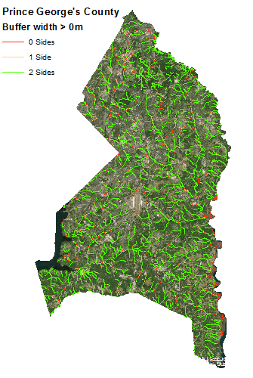

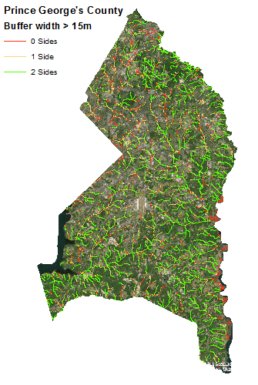

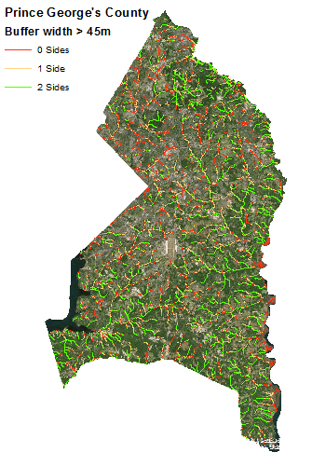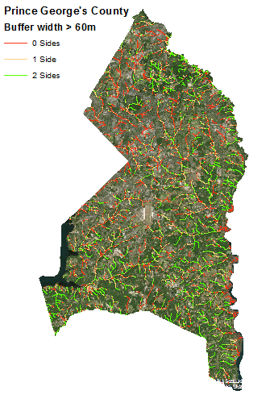

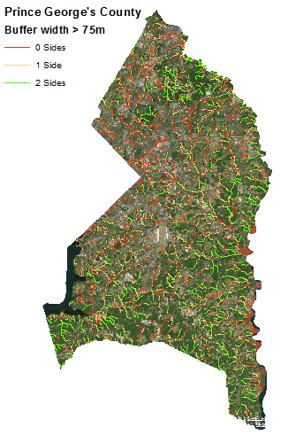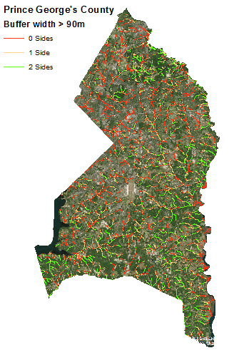

### Allegany County

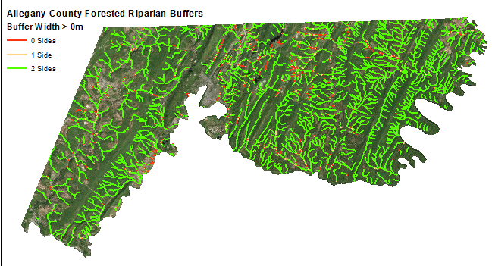



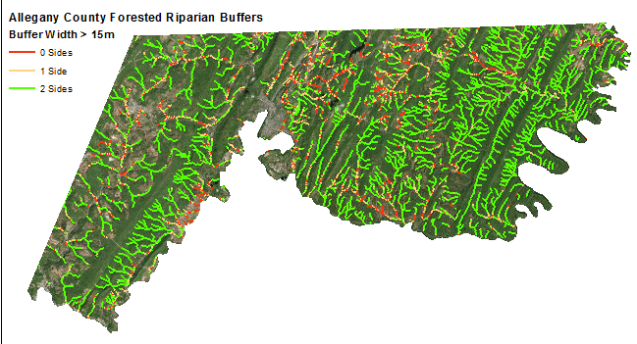



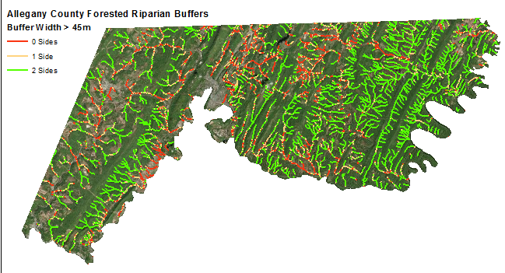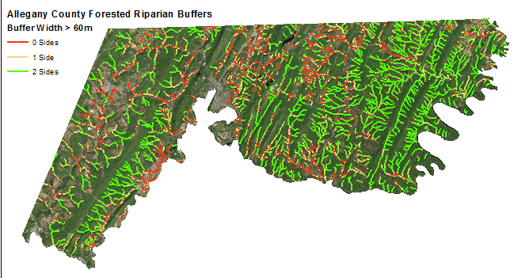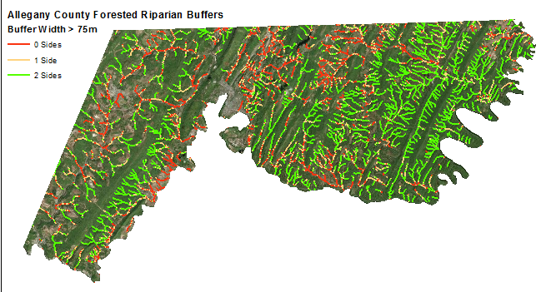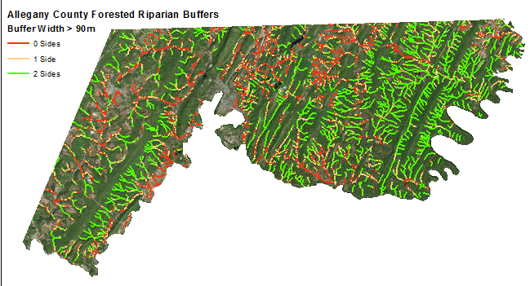

### Montgomery County



